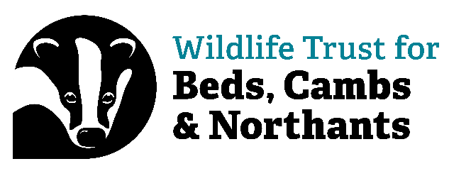
Volunteer Role: Northamptonshire Wider Countryside Voluntary Officer
Expression of Interest

Thank you for your interest in the role of Wider Countryside Voluntary Officer. It would be helpful if you could tell us a bit about yourself and why this role appeals to you. Please complete the following.

Section 1: Personal Details

I confirm that I am 18 years old or over: Yes/No (delete as applicable). NOTE: DO NOT FILL OUT THIS FORM IF YOU ARE UNDER 18, please contact us to find out what we can offer under 18s, or visit the website: Volunteer | Wildlife Trust for Beds, Cambs & Northants (wildlifebcn.org)

Name:__________________________________________________________________________________

Office use only
Support Officer: Group/Team:………………………………………………………………..

Home address including postcode:________________________________________________________________________________________________________________________________________________________________________________________________________________________________________________________________________________________________________________________________

Phone No. (Specify home/work/mobile):_________________________________________________________________

Email address: __________________________________________________________________________________

Do you hold a valid driving licence? Yes/No (delete as applicable).

Do you have access to a car which you could use to visit survey sites? – please note, this is not essential Yes/No (delete as applicable).

Section 2: On a separate page below, please tell us a bit about yourself. This might include the following:

- Why you would like to be a Wider Countryside Voluntary Officer and what you hope to gain from the experience, including if you have an interest in pursuing a career in wildlife conservation.

- Do you like days working outdoors (in all weather) as well as days at a computer? It would be useful to give examples of anything you have done in the past. Are you computer literate?

- Let us know if you have any experience of surveying wildlife (this could be habitats or species)? If you do, what did you enjoy most about the surveys?

- The Wider Countryside Team often work together on projects, but we also work independently to progress different aspects of our work. Can you tell us about a time when you have had to be self-motivated and organised?

- The Wider Countryside Voluntary Officer Role includes writing reports or letters to different audiences. Can you describe a couple of times you have produced written work for different audiences? What did you need to consider to make sure your work was suitable for the correct audience?

- Do you have any relevant education and / or experience / or interest in the area of wildlife conservation / natural history?

- You might like to include any other skills or attributes you have that you feel would make you suitable for this role.

Section 3: Important information:

Equality, Diversity and Inclusion
We’re wild about inclusion and want our staff and volunteers to be as diverse as wildlife. As an inclusive organisation we want our staff and volunteers to better reflect the communities in which we live and work. We actively encourage applications from people of all backgrounds, identities and cultures. We believe that diverse staff and volunteers will help us create our vision of ‘people close to nature, with land and seas rich in wildlife.’ We will not accept discrimination by staff or volunteers. A copy of the Equal Opportunities Policy is available upon request.

Recruitment Data Privacy Statement
In order to operate the Wildlife Trust for Bedfordshire, Cambridgeshire, and Northamptonshire’s (“The Trust”) volunteer recruitment system, we will collect and store personal information you submit via this form and any CV that you may provide. Some of the information on this form is mandatory in order for the Trust to consider your application or to meet our statutory monitoring and reporting responsibilities. However, where indicated, some of the information is optional and you can choose not to provide it.

By completing this form you give your consent for us to send you information regarding volunteering opportunities.

Would you be happy to hear from us about projects, events, and fundraising news by:
Post Yes / No (please delete as appropriate)
Telephone Yes / No (please delete as appropriate)
E-mail Yes / No (please delete as appropriate)

We will send you information as per your instructions above. If at any time you would like to change how we keep in touch, simply tell us and we’ll act on it straight away.

I understand my details will be held on the Wildlife Trust BCN database.. I certify that the information I have given is true and complete. I understand that any data I gather as part of volunteering will be used for the work of the Wildlife Trust BCN

Your signature Date_________________________

Please return to Katharine by email (Katharine.Banham@wildlifebcn.org)

Thank you. We will be in touch.

