December 2022
Dear Flit Vale Wildlife Trust Group Member
The end of the year is approaching fast and I think we all agree that weather-wise it has been a very strange one. I have had Salvias flowering in November and even some Honeysuckle flowered in the middle of the month! There is still much to see getting out and about and it has been lovely to see the winter thrushes arrive locally.
Previous Events: 21 November - AGM and talk on Conservation Agriculture by Brian Sims

A good number of members turned out on a rather chilly evening to listen to a fascinating talk by Brian. An alternative, sustainable way of growing crops which is kinder to the environment and beneficial to wildlife but ultimately providing the food we need with a growing population. We all enjoyed some refreshments during a lively discussion after the presentation!

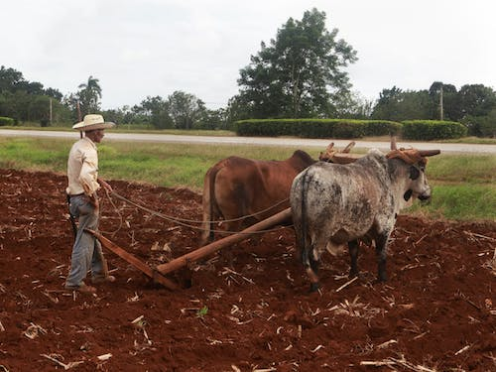 Ploughing with oxen

Future Events for 2023:

23 January (Zoom) 7:30pm –Dream Island: Two years on Skokholm, Pembrokeshire, talk by Steve Halton
After graduating from a wildlife illustration art degree at Carmarthen, Steve volunteered on Skomer Island for a few months, then was offered a job as Assistant Warden on Skokholm for two years. This is the story of a magical island with choughs, puffins and peregrines by day and Manx shearwaters and storm petrels by night. A tale of birds, big seas, flowers and cliffs and people who love wild places.
*Free, but donations welcome
10 February – Quiz Night at Maulden Village Hall, commencing 7:30pm £12.00 to include fish and chips or vegetarian option supper. Teams to be a maximum of 6.
Come and test your knowledge on a range of subjects and have an enjoyable and fun evening! You can now book in your teams for the event – just email Ann on the Flit Vale email with names of your team members, a team name and meal choices.

Important Information: Please note that under the terms of the Hall Licence, we cannot allow participants to bring alcohol on to the premises.
Of course, there will be beer, wine and soft drinks to purchase!
20 March – Talk by Dr Wilf Powell, Maulden Church Hall at 7:30pm – topic to be confirmed
Charge: £4.00

13 May – Butterfly Walk at Whipsnade Downs with Dr Wilf Powell. Meet in the National Trust car park at 1000.
Come and join butterfly enthusiast Wilf as we search for some of the lovely species to be found on the Downs.
Charge: £4.00
Parking is £3.50 for the day (ticket machines take card or cash payments) although it is free for National Trust members and blue badge holders.

31 May – Talk on Ampthill Churchyard and the Conservation Efforts followed by a tour of the churchyard – Event led by: Nigel Pollard

Nigel has been involved with this project for some time and will give a talk about how it began and how it is developing. We will then visit the site to see the results of the work33.

Charge: £4.00

ALSO …Not a Flit Vale event, but one you may wish to attend and support:

The Wildlife Trust for Beds, Cambs & Northants needs help to buy and transform land to make a bigger, better & more beautiful -
Great Fen
The great fen helps wildlife thrive & helps lock CO₂
Please join us for a buffet curry at: The Jalori Restaurant in Woburn Sands on
Monday 16th January 2023 at 7 – 7.30pm
TICKETS: £25 per head (this includes a £10 donation to help buy this land, which can be gift aided).
Every £10 raised could be worth £100 by the 10x lottery heritage funding
FOR MORE INFORMATION CALL OR TEXT: LINDA MARSHALL ON:
07941403445 or email: lindammarshall@hotmail.co.uk

Booking for Flit Vale events is essential, as places are limited. Please contact Ann by email: flitvale.info@gmail.com or ‘phone (leave a message or text if you prefer) 075801 78889 to reserve your place.
If you want to send an email to the Flit Vale group, please do not respond to the one with the newsletter – this is a BCN email address and correspondence can take some time to be forwarded due to many staff being part-time. I check the Flit Vale email regularly, so you will get a speedy response!

Last but certainly not least, the Flit Vale Committee would like to wish you all a very Happy Christmas and a healthy and wildlife-filled New Year!

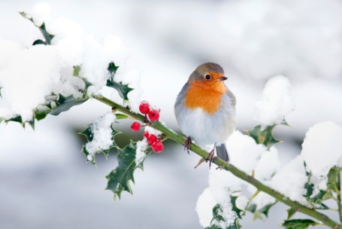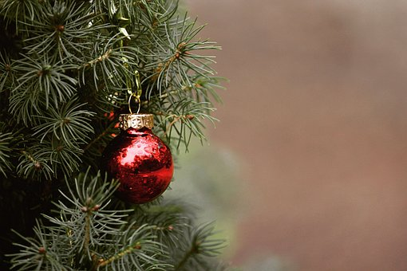
Ann
Ann de Winter (Events Coordinator)
Flit Vale Local Group
The Wildlife Trust for Bedfordshire, Cambridgeshire and Northamptonshire
Registered charity number: 1000412
www.wildlifebcn.org
Flit Vale Local Group

